**SMILE TREE DENTAL CLINICS**

**2011 ANNUAL REPORT**

**Submitted by Global Dental Relief**

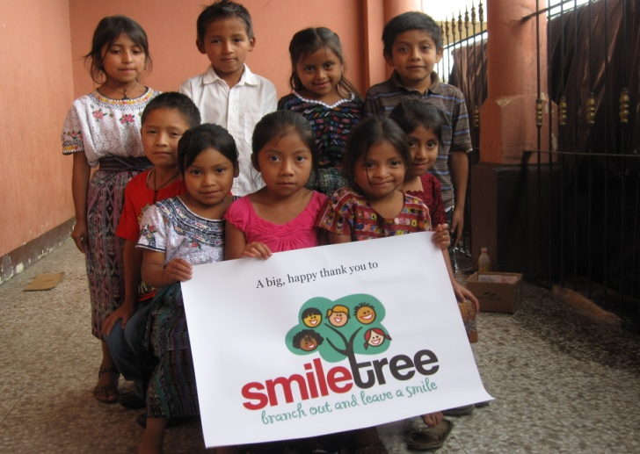

Since 2007, Smile Tree has sponsored dental clinics to serve children in need, in partnership with Global Dental Relief. This five year partnership has brought first-time and follow up care to over 11,126 children in three countries – an estimated $2.6 million in donated dental care for kids.

**HISTORY**

In 2007, Smile Tree initiated first time support of dental clinics in Guatemala to provide free dental care to children. Clinics are staffed by dental volunteers providing treatment and preventive care to children from orphanages and village schools located in the Mayan Highlands of Guatemala.

The partnership for Guatemalan children has grown and flourished over the past five years, as shown on the attached chart of dental care provided (Attachment 1). In 2007, Smile Tree sponsored two clinics and brought 652 children an estimated $174,670 in donated dental care (US equivalent $). In 2011, Smile Tree sponsored three clinics – reaching 1654 children with $510,860 in donated care.

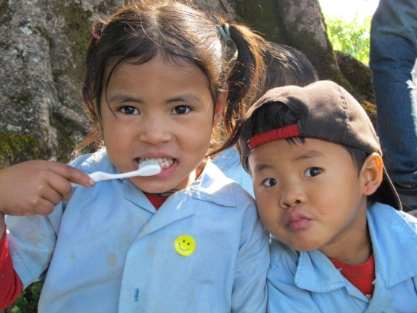 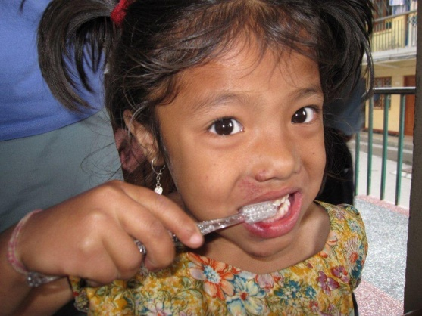

In 2010, Smile Tree expanded to add clinics for children in Nepal. Clinics in Nepal are held in Kathmandu, and serve charity schools and orphanages that house and educate children from the vast road less foothills and mountains of Nepal. An additional clinic is held in Bandipur, a Newari village situated in the foothills of the Annapurna range. In 2011, over 2,000 Nepali children received Smile Tree sponsored care.

In 2011, Smile Tree expanded once again – to serve children in northern India. Clinics held in Ladakh, India reached children from remote villages in a region at 12,000 feet in the shadow of the massive Himalayas. With support of the local Lion’s Club, children from orphanages, and government and charity schools received first time dental care.

**CARE PROVIDED**

Dental clinics take place over the course of six days. Clinics are set up in a local school or municipal building. Through the use of a generator and air compressor, clinics allow volunteer dental professionals to provide a full range of dental services.

Children are brought to the clinic class by class from local schools or orphanages. Each child receives an exam, cleaning, and all extractions and restorations required. If additional work is needed, children are recalled during the same clinic until dental care is complete. Children also receive a toothbrush, along with brushing instruction and oral hygiene education.

Each school population returns every two years to insure children receive long-term follow up care and oral health instruction.

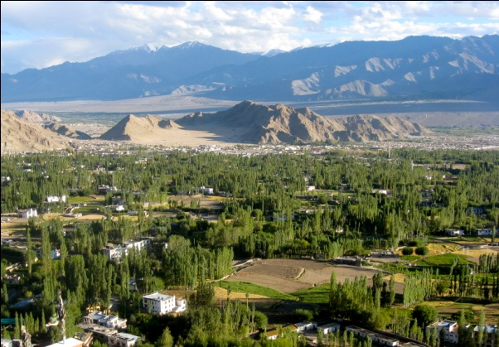 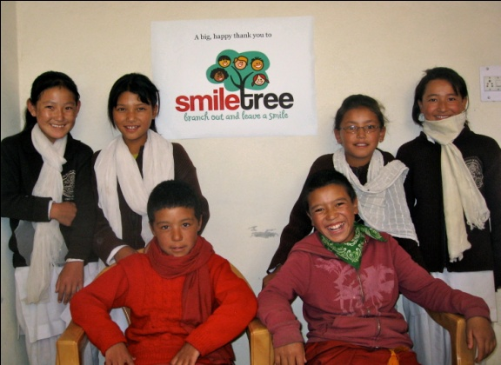

**2011 ACCOMPLISHMENTS**

In 2011, Smile Tree sponsored a total of eight clinics in 3 countries – three in Guatemala; two in Kathmandu, Nepal; one in Bandipur, Nepal; and two in Ladakh, India.

Clinics in these locations reached a record number of children -- 4,183 children received $953,770 in donated dental care, including 1110 cleanings, 2942 restorations, 806 extractions, and 2353 fluoride treatments.

In total, care to children has expanded from 652 patients in 2007 to 4,183 in 2011 – **an increase over five years of 231 percent in children served.**

Smile Tree’s support is vital to reaching children without access to care. Global Dental Relief looks forward to partnering with Smile Tree in reaching more children in 2012 and beyond.

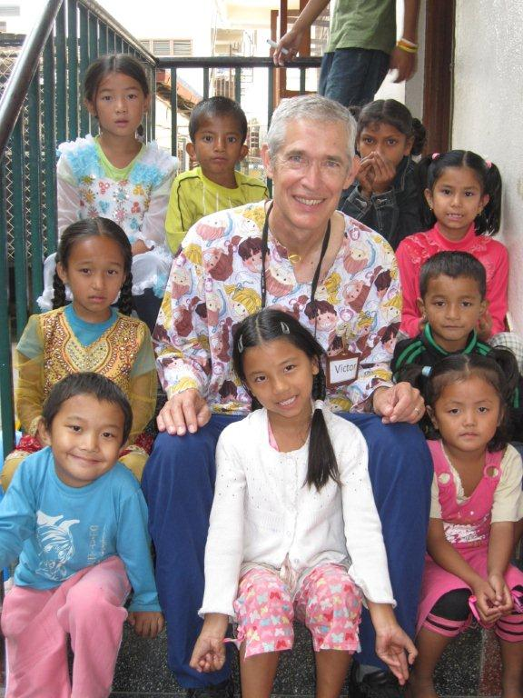 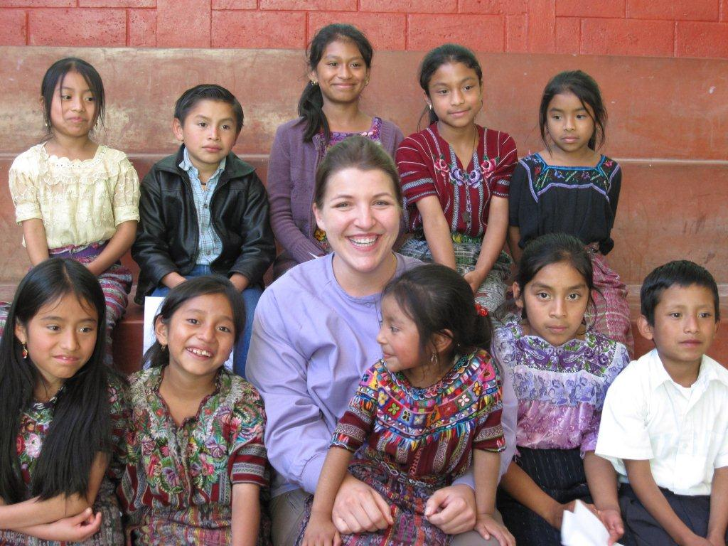

**SMILE TREE ACCOMPLISHMENTS -- 2007- 2011**

The highlights of five years of clinics are as follows:

**- Smile Tree has sponsored twenty dental camps in three countries – India, Nepal, and Guatemala.** Guatemala camps were held in San Martin Jilotepeque and Patzun in the Mayan Highlands of the country. Nepal clinics take place in Kathmandu and the village of Bandipur. Our camps in India are held in the northern part of the country in the town of Ladakh at an altitude of 12,000 ft.

- **In total, twenty dental camps have treated 11,126 children and produced $2,611,140 in donated dental care (US $ equivalent).** Work includes: 2559 cleanings, 8390 fillings, 2597 extractions of infected teeth and 5677 fluoride applications.

- **Dental camp volunteers over the five years of operation include: 82 dentists, 44 hygienists and 172 non-medical volunteers**

- **During each visit, children receive a toothbrush and extensive tooth brushing and oral hygiene instruction.** The goal is to build strong oral health habits that are reinforced by continued treatment of each population every two years.

**THE CHILDREN WE SERVE**

Smile Tree sponsored clinics are filled with children – some are anxious, most chatter excitedly, and all point and avidly discuss the proceedings. Each day begins with long lines of children, often so intent when their name is called that they walk the distance to the dental chair with mouths wide open.

Dental care is crucial to the overall health of a child. Ongoing care significantly reduces infection, chronic pain and susceptibility to systemic disease, giving children healthy smiles and leading to longer, healthier lives.

Our volunteers thrive on their interactions with these special kids and 60 percent of them will return to volunteer to experience these joyful moments again.

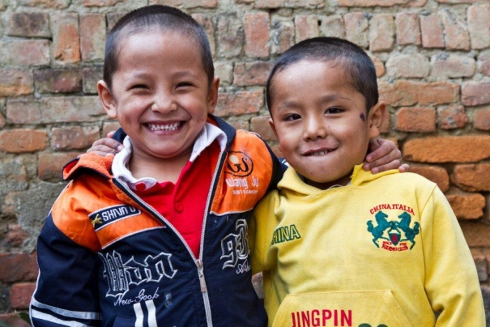 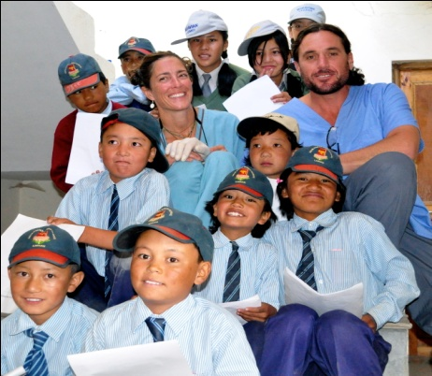

**THE YEARS AHEAD -- 2012 CLINICS**

Date Location Volunteers Children Treated

**GUATEMALA**

May 20 - 26 San Martin Jilotepeque 6 Dental Chairs 400-450 Patients

July 29 – Aug 3 San Martin Jilotepeque 6 Dental Chairs 400-450 Patients

Aug 6 – 10 San Martin Jilotepeque 6 Dental Chairs 400-450 Patients

**INDIA, LADAKH**

Sept 5 - 12 Leh 6 Dental Chairs 500-600 Patients

Sept 19 - 26 Leh 6 Dental Chairs 500-600 Patients

**NEPAL**

Nov 1 – 8 Kathmandu 6 Dental Chairs 900-1000 Patients

Nov 17 – 24 Kathmandu 6 Dental Chairs 900-1000 Patients

Nov 26 – 30 Bandipur 3 Dental Chairs 200-300 Patients

### SUMMARY

This partnership dramatically increases the capacity of Smile Tree and Global Dental Relief to reach more children with direct care. We look forward to many years working together to ensure more children achieve a healthy and brighter future.