**Annual Report - 2016 SmileTree Clinic Sponsorship**

SmileTree and Global Dental Relief have been partners for eleven years, providing first time and follow up dental care for children. Together, this partnership has treated 45,199 children with $10.7 million in donated dental care.  Thank you SmileTree!

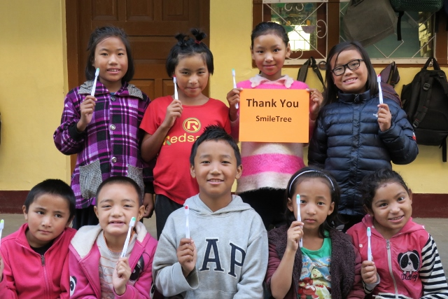

Treating 45,199 children is an amazing gift to children in all three countries where we work as partners – Nepal, India and Guatemala.  Over eleven years, this sponsorship has supported the work of 288 dentists, 134 hygienists and 562 non-dental volunteers.  (All the details on these figures, by year, are in Attachment 1: 2007 - 2017 Statistics).

This past year was also a banner year.  In 2017, SmileTree sponsored care for 5,963 children in seven clinics. Volunteers provided children with a total of $1.4 million in donated dental care – care they would never otherwise be able to receive given their lack of access to even basic human services.

We at Global Dental Relief are honored by SmileTree’s longstanding support and caring for this work – thank you!

**2007 – 2017 Summary**

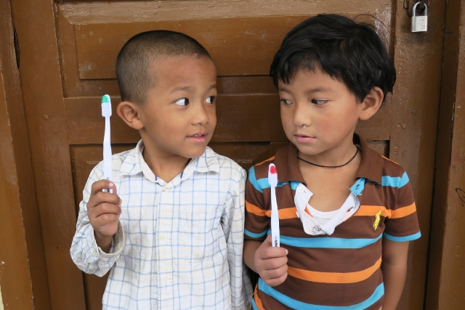Since 2007, SmileTree has sponsored 65 week-long dental clinics in three countries- Nepal, India and Guatemala. Children treated at these clinics typically come from local charity or government schools and most students live with families subsisting well below poverty levels.  For these children, there is little access to services such as dental care.

Living without dental care, children frequently suffer from chronic pain and infection due to small cavities which are left untreated and eventually expand to encompass an entire tooth. A child in pain with infection is unable to sleep or eat properly. They fail to thrive in school and in daily life.

Supported by SmileTree, GDR volunteers working in these three countries have restored 45,199 students to dental health, giving them better chance to overcome their often challenging daily circumstances.  The average value of the dental care provided was $223 (US equivalent) per child.

Over eleven years, GDR volunteers at SmileTree clinics included 288 dentists, 134 hygienists and 562 non-dental volunteers.  Many of these volunteers return over and over again to continue care for these special children in need.

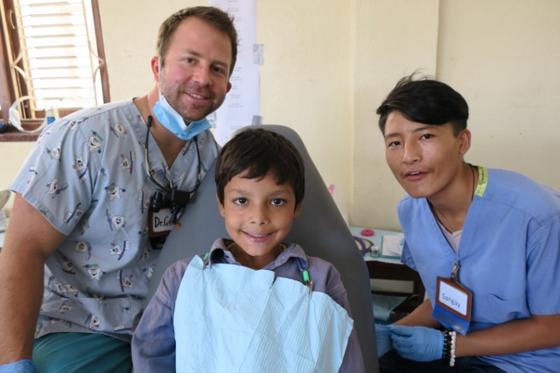Each clinic follows GDR’s model of care, working directly with schools to bring children class by class. During their visit each student received an exam, followed by restorations, extractions. Children returned on subsequent days until all designated treatment was complete and they were restored to full oral health.

Each child also received oral health instruction, repeated at three points during their clinic visit. They were given a new toothbrush and a preventive fluoride treatment.  Children will return to the clinic every 2 years for follow up care.

Clinics are a special experience for volunteers and patients alike. Each day is packed with excited, chattering children curiously watching the elaborate proceedings of masked doctors and whirring machines in the clinic.

Volunteers are moved by the children’s sometimes anxious smiles and their excited recitations of new knowledge about tooth brushing. After waiting in line outside the clinic door, students are called one-by- one to a dental chair. Over and over again, they give us a big grin, climb into the chair and lay down – many times with their mouth wide open for the dentist.

We love these kids with big eyes -- they brought joy to our days and make the clinic days pass in a blur of smiling faces.

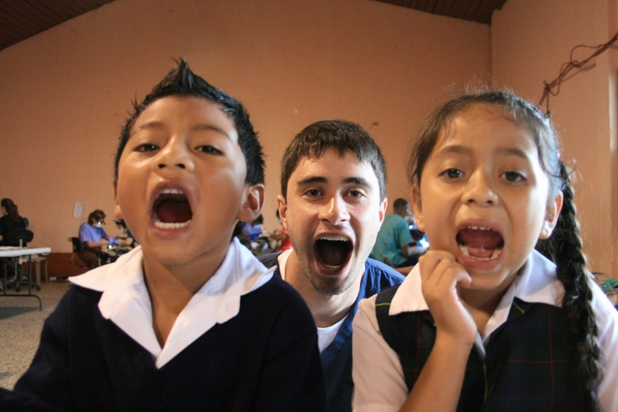

**2017 Sponsorship**

In 2017, SmileTree sponsored dental clinics in Nepal, India and Guatemala serving 5963 children. **By restoring these children to health, SmileTree has made a profound contribution to the health of children and their overall ability to thrive and lead healthy lives.**

SmileTree sponsored clinics I 2017 hosted 35 dentists, 12 hygienists and 53 general volunteers. Here are the statistics for the seven sponsored clinics:

Patients Served 5963

Cleanings 1106

Restorations 4001

Extractions 1168

Fluoride Treatment 3721

Total Donated Value $1,412,220

Clinics at each of SmileTree’s locations are set up in local classrooms or civic buildings. In Nepal, the clinic takes place in a classroom of the Shree Mangal School in Kathmandu. In Guatemala, clinics are held in the civic building in the town center, and in India work is done in the local Lion’s Club facility.

In each of these locations, rooms are transformed into field clinics with seven dental stations for dentists and hygienists, an education area for oral health instruction and a full sterilization facility. Children line up each day, class by class, and are given, exams, treatment and education.

**Conclusion**

**Smile**Tree’s long term support has meant life-changing dental care for children. The impact of this sponsorship is huge – 45,199 children served with first time dental care means these children are living healthier lives with healthy smiles.

We are honored by the support of SmileTree over many years. Thank you, and thank you from the children we serve together!

